2.TerraformAzure (VNet Peering)

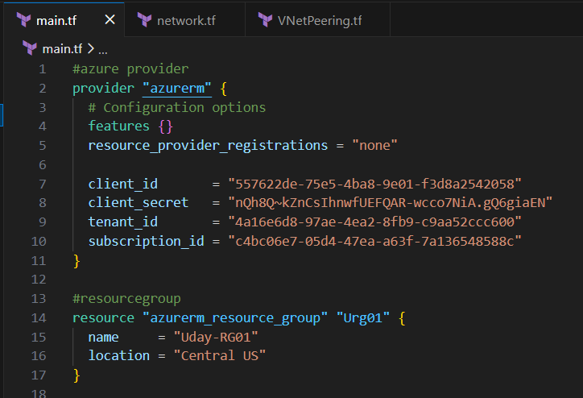

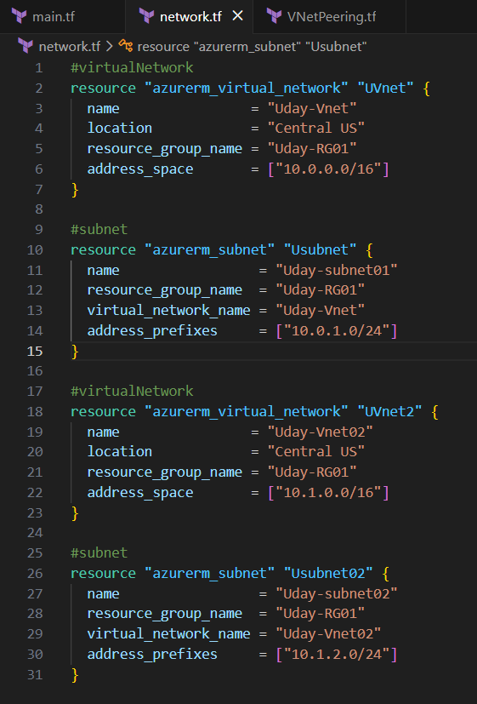

- Below we have to do peering from both sides.
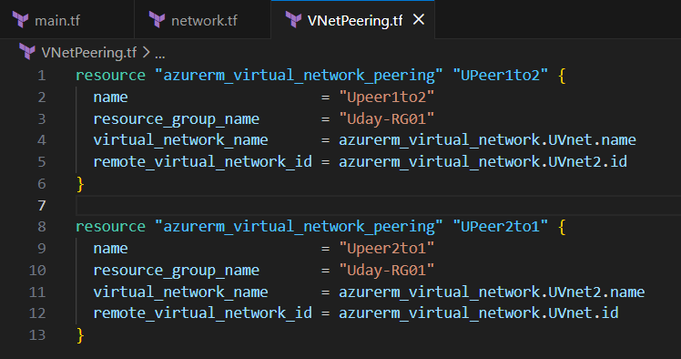
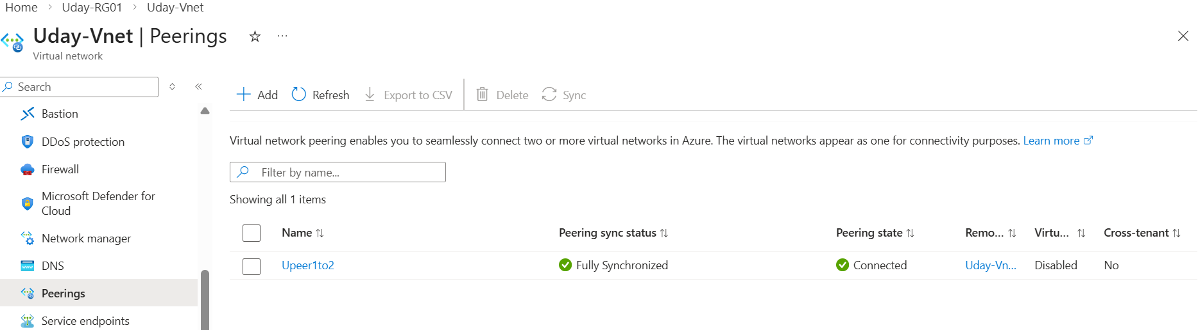
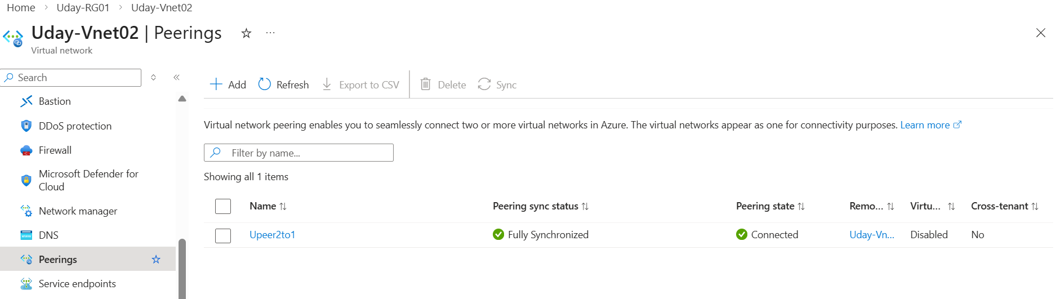

- Below let’s create with Variables
- Let’s define variables first below
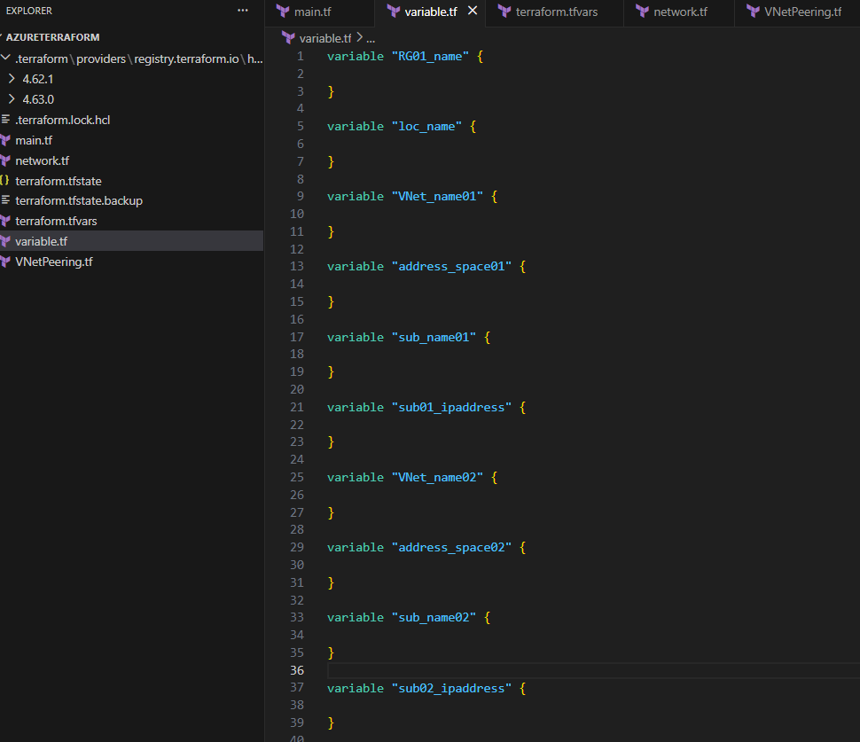
- Next give values for above variables, below.
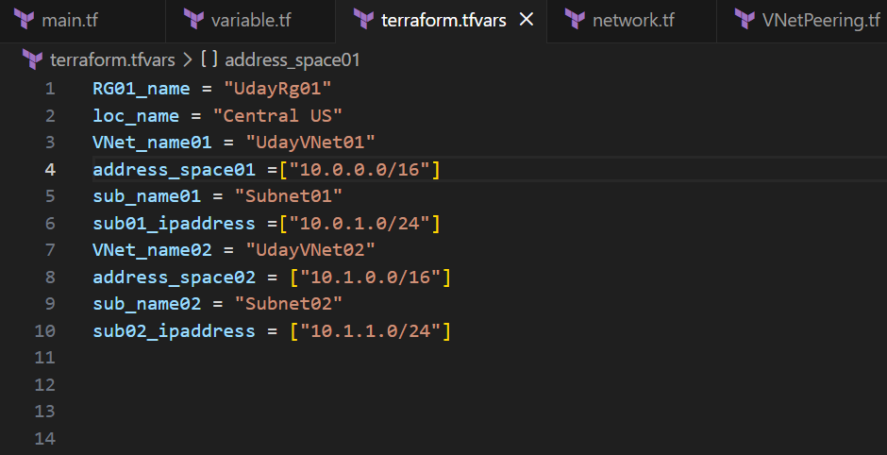
- Next create resources for below for VNet Peering.
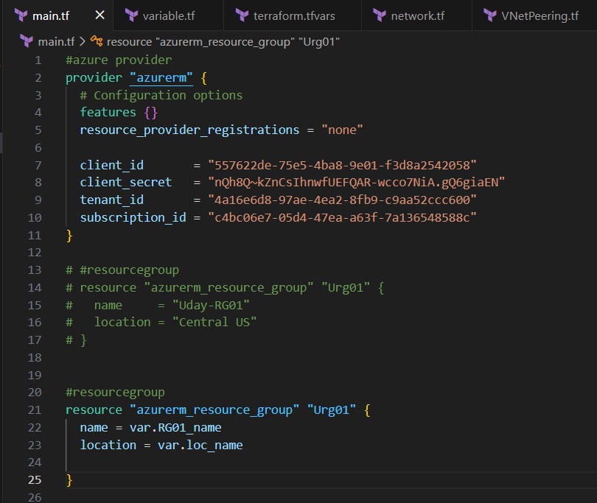

- Both VNets & Subnets below
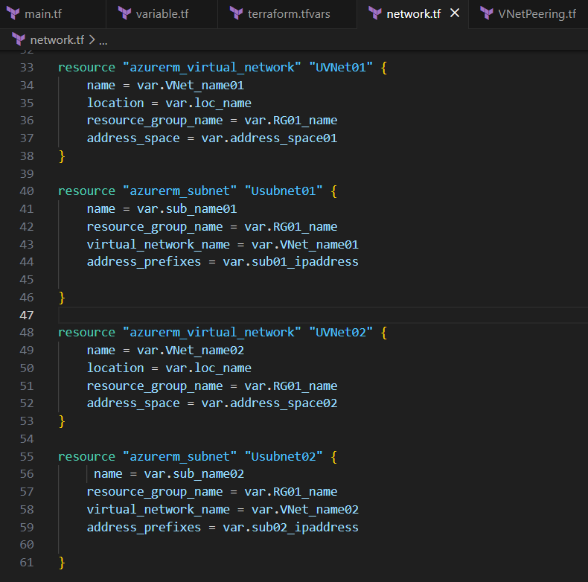

- For Peering copy RG & VNet (Resourcetype,ReferenceName) and paste below.
